Supplementary Materials for
Metric-dependent crop water-management priorities in Pakistan’s Indus Basin: Remote-sensing evidence for irrigation screening
Muhammad Ahmad Akram, Umar Farooq, Rana Ammar Aslam, Naeem Saddique, Abdul Nasir, Muhammad Ali Hassan Khan, Mannan Aleem, Muhammad Maaz Tanveer, Muhammad Abubakar Shafique, and Syed Muhammed Subtain Abbas

This file includes Sections S1-S12, Tables S1-S12, and Figures S1-S17. Complete machine-readable versions of all tables, analytical rasters, boundary files, and code are archived at https://github.com/Ahmad5046/indus-basin-crop-water-supplementary-materials. The immutable repository revision used for submission is identified in the manuscript's Data Availability and Supplementary Materials statements.
S1. Analytical scope and reproducibility
The analytical support is cropland within the Pakistan portion of the Indus drainage basin. It is not an official canal-command delineation. The crop map describes the 2023 seasonal extent: crop-hectares can exceed unique physical area under double cropping, maize combines spring and autumn cycles, and sugarcane is treated as annual. Water accounting is crop-season based and residual blue ET is not measured irrigation withdrawal.

S2. Predictor and classification details
The Rabi stack contains 42 predictors and the Kharif stack 47. Predictor families include period-specific Sentinel-2 NDVI, EVI, NDWI, LSWI, and SAVI; full-season Sentinel-2 and Landsat optical bands and indices; Sentinel-1 median VV, VH, and VV-VH; and SRTM elevation and slope. Missing predictors were filled with -0.25 before sampling. Both models used 300 trees, minimum leaf population 2, bag fraction 0.70, default variables per split, no maximum-node limit, and classifier seed 20230709. Reference points were assigned by whole 0.05-degree blocks using a deterministic SHA-256 rule with seed 20230709.

Table S1. Class-level validation diagnostics
Season | Class Code | Crop Name | Validation Support | Predicted Support | Correct | Producer Accuracy | User Accuracy | F1
Rabi | 1 | Wheat | 467.000 | 549.000 | 438.000 | 0.938 | 0.798 | 0.862
Rabi | 4 | Sugarcane | 125.000 | 115.000 | 97.000 | 0.776 | 0.843 | 0.808
Rabi | 5 | Maize | 214.000 | 203.000 | 193.000 | 0.902 | 0.951 | 0.926
Rabi | 6 | Other cropland | 474.000 | 413.000 | 365.000 | 0.770 | 0.884 | 0.823
Kharif | 2 | Rice | 517.000 | 523.000 | 478.000 | 0.925 | 0.914 | 0.919
Kharif | 3 | Cotton | 320.000 | 339.000 | 284.000 | 0.887 | 0.838 | 0.862
Kharif | 4 | Sugarcane | 436.000 | 454.000 | 397.000 | 0.911 | 0.874 | 0.892
Kharif | 5 | Maize | 587.000 | 614.000 | 491.000 | 0.836 | 0.800 | 0.818
Kharif | 6 | Other cropland | 529.000 | 459.000 | 380.000 | 0.718 | 0.828 | 0.769

Table S2. Season-level validation diagnostics
Season | Overall Accuracy | Kappa | Balanced Accuracy | Macro F1 | Training Samples | Validation Samples | Validation Blocks | Interpretation
Rabi | 0.854 | 0.788 | 0.846 | 0.855 | 5535.000 | 1280.000 | NA | spatial-block holdout; not area-probability sampled
Kharif | 0.850 | 0.811 | 0.855 | 0.852 | 9763.000 | 2389.000 | NA | spatial-block holdout; not area-probability sampled

S3. Crop-area scenario
The official-area-constrained scenario multiplies mapped mean crop water depth and mapped yield composition by the ratio of official harvested area to mapped crop-season area. It is a first-order structural scenario, not a confidence interval. Because area and production are scaled by the same factor, crop-level VWF remains unchanged while water volume and production scale directly.

Table S3. Mapped and official-area-constrained crop scenarios
Crop Name | Mapped Area Ha | Official Harvested Area Ha | Mapped Minus Official Pct | Mapped Total Water Km3 | Official Area Scaled Total Water Km3 | Mapped Total Vwf M3 T
Wheat | 7,930,296 | 8,477,154 | -6.451 | 26.468 | 28.293 | 1066.851
Rice | 4,156,694 | 2,969,151 | 39.996 | 15.284 | 10.918 | 1548.604
Cotton | 1,293,009 | 1,978,787 | -34.656 | 5.662 | 8.665 | 2076.197
Sugarcane | 1,647,041 | 1,284,439 | 28.230 | 12.965 | 10.110 | 125.629
Maize | 2,770,262 | 1,710,539 | 61.953 | 19.635 | 12.124 | 1237.948

S4. Product-chain structural sensitivity
The primary endpoint combines WaPOR v3 AETI with CHIRPS rainfall; the comparison endpoint combines MODIS ET with ERA5-Land rainfall. Endpoints are reported directly. No uniform interpolation, Monte Carlo distribution, or confidence interval is used.

Table S4. Product-chain endpoints
Crop Name | Product Chain | Total Water Mm | Green Water Mm | Blue Water Mm | Total Vwf M3 T | Water Productivity Kg M3
Wheat | WaPOR-CHIRPS | 333.753 | 86.571 | 247.182 | 1066.851 | 0.937
Wheat | MODIS-ERA5-Land | 133.591 | 86.845 | 46.746 | 427.028 | 2.342
Rice | WaPOR-CHIRPS | 367.707 | 225.058 | 142.649 | 1548.604 | 0.646
Rice | MODIS-ERA5-Land | 98.240 | 97.696 | 0.544 | 413.738 | 2.417
Cotton | WaPOR-CHIRPS | 437.882 | 197.116 | 240.766 | 2076.197 | 0.482
Cotton | MODIS-ERA5-Land | 116.879 | 113.785 | 3.094 | 554.177 | 1.804
Sugarcane | WaPOR-CHIRPS | 787.152 | 321.902 | 465.251 | 125.629 | 7.960
Sugarcane | MODIS-ERA5-Land | 241.894 | 226.641 | 15.253 | 38.606 | 25.903
Maize | WaPOR-CHIRPS | 708.773 | 371.337 | 337.436 | 1237.948 | 0.808
Maize | MODIS-ERA5-Land | 258.035 | 255.168 | 2.867 | 450.686 | 2.219

Table S5. Direct endpoint structural envelope
Crop Name | Metric | Primary Wapor Chirps | Comparison Modis Era5 Land | Absolute Difference | Comparison Minus Primary Pct
Wheat | green_water_mm | 86.571 | 86.845 | 0.274 | 0.317
Wheat | blue_water_mm | 247.182 | 46.746 | -200.436 | -81.088
Wheat | total_water_mm | 333.753 | 133.591 | -200.162 | -59.973
Wheat | green_vwf_m3_t | 276.726 | 277.603 | 0.877 | 0.317
Wheat | blue_vwf_m3_t | 790.125 | 149.426 | -640.699 | -81.088
Wheat | total_vwf_m3_t | 1066.851 | 427.028 | -639.823 | -59.973
Wheat | water_productivity_kg_m3 | 0.937 | 2.342 | 1.404 | 149.831
Wheat | blue_dependency_pct | 74.061 | 34.992 | -39.069 | -52.753
Rice | green_water_mm | 225.058 | 97.696 | -127.362 | -56.591
Rice | blue_water_mm | 142.649 | 0.544 | -142.105 | -99.619
Rice | total_water_mm | 367.707 | 98.240 | -269.467 | -73.283
Rice | green_vwf_m3_t | 947.836 | 411.448 | -536.387 | -56.591
Rice | blue_vwf_m3_t | 600.768 | 2.289 | -598.479 | -99.619
Rice | total_vwf_m3_t | 1548.604 | 413.738 | -1134.866 | -73.283
Rice | water_productivity_kg_m3 | 0.646 | 2.417 | 1.771 | 274.296
Rice | blue_dependency_pct | 38.794 | 0.553 | -38.241 | -98.574
Cotton | green_water_mm | 197.116 | 113.785 | -83.331 | -42.275
Cotton | blue_water_mm | 240.766 | 3.094 | -237.672 | -98.715
Cotton | total_water_mm | 437.882 | 116.879 | -321.003 | -73.308
Cotton | green_vwf_m3_t | 934.614 | 539.506 | -395.108 | -42.275
Cotton | blue_vwf_m3_t | 1141.583 | 14.670 | -1126.912 | -98.715
Cotton | total_vwf_m3_t | 2076.197 | 554.177 | -1522.020 | -73.308
Cotton | water_productivity_kg_m3 | 0.482 | 1.804 | 1.323 | 274.645
Cotton | blue_dependency_pct | 54.984 | 2.647 | -52.337 | -95.185
Sugarcane | green_water_mm | 321.902 | 226.641 | -95.260 | -29.593
Sugarcane | blue_water_mm | 465.251 | 15.253 | -449.998 | -96.722
Sugarcane | total_water_mm | 787.152 | 241.894 | -545.259 | -69.270
Sugarcane | green_vwf_m3_t | 51.375 | 36.172 | -15.203 | -29.593
Sugarcane | blue_vwf_m3_t | 74.254 | 2.434 | -71.819 | -96.722
Sugarcane | total_vwf_m3_t | 125.629 | 38.606 | -87.023 | -69.270
Sugarcane | water_productivity_kg_m3 | 7.960 | 25.903 | 17.943 | 225.412
Sugarcane | blue_dependency_pct | 59.106 | 6.305 | -52.800 | -89.332
Maize | green_water_mm | 371.337 | 255.168 | -116.169 | -31.284
Maize | blue_water_mm | 337.436 | 2.867 | -334.569 | -99.150
Maize | total_water_mm | 708.773 | 258.035 | -450.738 | -63.594
Maize | green_vwf_m3_t | 648.580 | 445.678 | -202.902 | -31.284
Maize | blue_vwf_m3_t | 589.367 | 5.007 | -584.360 | -99.150
Maize | total_vwf_m3_t | 1237.948 | 450.686 | -787.262 | -63.594
Maize | water_productivity_kg_m3 | 0.808 | 2.219 | 1.411 | 174.681
Maize | blue_dependency_pct | 47.608 | 1.111 | -46.497 | -97.666

S5. Fixed-extent temporal context
The 2018-2022 baseline and 2023 values use the fixed 2023 crop masks. They describe hydroclimatic/product variation over a short context window, not historical crop-area change or a long-term climatology.

Table S6. Fixed-2023-extent temporal context
Crop Name | Metric | Baseline Years | Baseline N | Baseline Mean | Baseline Sd | Value 2023 | Departure | Departure Pct | Standardized Departure | Scope Note
Wheat | WaPOR AETI | 2018-2022 | 5.000 | 282.907 | 23.375 | 305.578 | 22.670 | 8.013 | 0.970 | fixed validated 2023 crop extent; short product context, not long-term climatology
Wheat | CHIRPS rainfall | 2018-2022 | 5.000 | 171.499 | 57.682 | 115.911 | -55.589 | -32.413 | -0.964 | fixed validated 2023 crop extent; short product context, not long-term climatology
Wheat | Primary blue dependency | 2018-2022 | 5.000 | 48.902 | 11.581 | 59.804 | 10.903 | 22.295 | 0.941 | fixed validated 2023 crop extent; short product context, not long-term climatology
Rice | WaPOR AETI | 2018-2022 | 5.000 | 447.013 | 18.216 | 385.396 | -61.617 | -13.784 | -3.383 | fixed validated 2023 crop extent; short product context, not long-term climatology
Rice | CHIRPS rainfall | 2018-2022 | 5.000 | 307.427 | 47.088 | 318.187 | 10.760 | 3.500 | 0.229 | fixed validated 2023 crop extent; short product context, not long-term climatology
Rice | Primary blue dependency | 2018-2022 | 5.000 | 47.872 | 7.600 | 39.174 | -8.698 | -18.169 | -1.144 | fixed validated 2023 crop extent; short product context, not long-term climatology
Cotton | WaPOR AETI | 2018-2022 | 5.000 | 501.249 | 38.568 | 408.743 | -92.506 | -18.455 | -2.398 | fixed validated 2023 crop extent; short product context, not long-term climatology
Cotton | CHIRPS rainfall | 2018-2022 | 5.000 | 197.525 | 86.609 | 202.559 | 5.034 | 2.549 | 0.058 | fixed validated 2023 crop extent; short product context, not long-term climatology
Cotton | Primary blue dependency | 2018-2022 | 5.000 | 62.038 | 9.703 | 51.626 | -10.412 | -16.783 | -1.073 | fixed validated 2023 crop extent; short product context, not long-term climatology
Sugarcane | WaPOR AETI | 2018-2022 | 5.000 | 876.973 | 34.337 | 798.408 | -78.564 | -8.959 | -2.288 | fixed validated 2023 crop extent; short product context, not long-term climatology
Sugarcane | CHIRPS rainfall | 2018-2022 | 5.000 | 384.319 | 78.809 | 359.750 | -24.569 | -6.393 | -0.312 | fixed validated 2023 crop extent; short product context, not long-term climatology
Sugarcane | Primary blue dependency | 2018-2022 | 5.000 | 59.253 | 7.086 | 57.298 | -1.955 | -3.299 | -0.276 | fixed validated 2023 crop extent; short product context, not long-term climatology
Maize | WaPOR AETI | 2018-2022 | 5.000 | 713.881 | 16.826 | 665.658 | -48.223 | -6.755 | -2.866 | fixed validated 2023 crop extent; short product context, not long-term climatology
Maize | CHIRPS rainfall | 2018-2022 | 5.000 | 642.683 | 63.916 | 574.696 | -67.986 | -10.579 | -1.064 | fixed validated 2023 crop extent; short product context, not long-term climatology
Maize | Primary blue dependency | 2018-2022 | 5.000 | 32.323 | 4.722 | 31.807 | -0.516 | -1.595 | -0.109 | fixed validated 2023 crop extent; short product context, not long-term climatology

S6. Hotspot threshold sensitivity
The district score adds one point each for high blue-water volume, high total VWF, and low WP. Threshold pairs 70/30, 75/25, 80/20, and 90/10 were applied both to all 108 computable districts and to the 76 districts with at least 25,000 mapped crop-hectares. These are internal diagnostic priorities, not environmental or legal thresholds.

Table S7. Hotspot-count sensitivity
Scope | District Count | Threshold Pair | High Quantile | Low Quantile | Blue Volume Cutoff Km3 | Total Vwf Cutoff M3 T | Water Productivity Cutoff Kg M3 | Score 0 Count | Score 1 Count | Score 2 Count | Score 3 Count | Priority Score Ge 2 Count
all computable districts | 108 | 70/30 | 0.700 | 0.300 | 0.606 | 1658.319 | 0.603 | 42 | 33 | 33 | 0 | 33
all computable districts | 108 | 75/25 | 0.750 | 0.250 | 0.713 | 2012.244 | 0.497 | 54 | 27 | 27 | 0 | 27
all computable districts | 108 | 80/20 | 0.800 | 0.200 | 0.818 | 2302.369 | 0.434 | 64 | 22 | 22 | 0 | 22
all computable districts | 108 | 90/10 | 0.900 | 0.100 | 1.181 | 3122.410 | 0.320 | 86 | 11 | 11 | 0 | 11
districts with mapped area >=25,000 ha | 76 | 70/30 | 0.700 | 0.300 | 0.791 | 988.038 | 1.015 | 31 | 22 | 22 | 1 | 23
districts with mapped area >=25,000 ha | 76 | 75/25 | 0.750 | 0.250 | 0.996 | 1148.249 | 0.872 | 38 | 19 | 19 | 0 | 19
districts with mapped area >=25,000 ha | 76 | 80/20 | 0.800 | 0.200 | 1.139 | 1444.592 | 0.692 | 44 | 16 | 16 | 0 | 16
districts with mapped area >=25,000 ha | 76 | 90/10 | 0.900 | 0.100 | 1.281 | 2451.910 | 0.408 | 60 | 8 | 8 | 0 | 8

Table S8. District hotspot stability (first 40 rows; complete CSV supplied separately)
Scope | Gaul1 Name | Gaul2 Name | Mapped Area Ha | Threshold Tests | Priority Count | Minimum Score | Maximum Score | Priority Stability
all computable districts | Khyber Pakhtunkhwa | Buner | 64,589 | 4.000 | 4 | 2.000 | 2.000 | priority under all thresholds
all computable districts | Islamabad | Islamabad | 32,749 | 4.000 | 4 | 2.000 | 2.000 | priority under all thresholds
all computable districts | Khyber Pakhtunkhwa | Khyber | 15,704 | 4.000 | 4 | 2.000 | 2.000 | priority under all thresholds
all computable districts | Khyber Pakhtunkhwa | Orakzai | 14,550 | 4.000 | 4 | 2.000 | 2.000 | priority under all thresholds
all computable districts | Khyber Pakhtunkhwa | Abbottabad | 14,007 | 4.000 | 4 | 2.000 | 2.000 | priority under all thresholds
all computable districts | Khyber Pakhtunkhwa | South Waziristan | 11,463 | 4.000 | 4 | 2.000 | 2.000 | priority under all thresholds
all computable districts | Khyber Pakhtunkhwa | Karak | 10,357 | 4.000 | 4 | 2.000 | 2.000 | priority under all thresholds
all computable districts | Khyber Pakhtunkhwa | Batagram | 6,423 | 4.000 | 4 | 2.000 | 2.000 | priority under all thresholds
all computable districts | Khyber Pakhtunkhwa | Shangla | 5,773 | 4.000 | 4 | 2.000 | 2.000 | priority under all thresholds
all computable districts | Khyber Pakhtunkhwa | Tor Ghar | 1,762 | 4.000 | 4 | 2.000 | 2.000 | priority under all thresholds
all computable districts | Balochistan | Pishin | 154 | 4.000 | 4 | 2.000 | 2.000 | priority under all thresholds
all computable districts | Punjab | Rawalpindi | 246,278 | 4.000 | 3 | 0.000 | 2.000 | threshold-sensitive priority
all computable districts | Khyber Pakhtunkhwa | Haripur | 66,371 | 4.000 | 3 | 0.000 | 2.000 | threshold-sensitive priority
all computable districts | Khyber Pakhtunkhwa | Bajaur | 59,996 | 4.000 | 3 | 0.000 | 2.000 | threshold-sensitive priority
all computable districts | Khyber Pakhtunkhwa | Lower Dir | 52,253 | 4.000 | 3 | 0.000 | 2.000 | threshold-sensitive priority
all computable districts | Khyber Pakhtunkhwa | Mansehra | 43,831 | 4.000 | 3 | 0.000 | 2.000 | threshold-sensitive priority
all computable districts | Khyber Pakhtunkhwa | Swat | 43,208 | 4.000 | 3 | 0.000 | 2.000 | threshold-sensitive priority
all computable districts | Khyber Pakhtunkhwa | Kurram | 29,969 | 4.000 | 3 | 0.000 | 2.000 | threshold-sensitive priority
all computable districts | Khyber Pakhtunkhwa | Hangu | 24,869 | 4.000 | 3 | 0.000 | 2.000 | threshold-sensitive priority
all computable districts | Balochistan | Kachhi | 21,531 | 4.000 | 3 | 0.000 | 2.000 | threshold-sensitive priority
all computable districts | Balochistan | Ziarat | 6,593 | 4.000 | 3 | 0.000 | 2.000 | threshold-sensitive priority
all computable districts | Khyber Pakhtunkhwa | Kolai Palas Kohistan | 1,072 | 4.000 | 3 | 0.000 | 2.000 | threshold-sensitive priority
all computable districts | Balochistan | Jhal Magsi | 40,466 | 4.000 | 2 | 0.000 | 2.000 | threshold-sensitive priority
all computable districts | Khyber Pakhtunkhwa | Mohmand | 22,926 | 4.000 | 2 | 0.000 | 2.000 | threshold-sensitive priority
all computable districts | Balochistan | Sibi | 20,280 | 4.000 | 2 | 0.000 | 2.000 | threshold-sensitive priority
all computable districts | Khyber Pakhtunkhwa | Upper Dir | 13,051 | 4.000 | 2 | 0.000 | 2.000 | threshold-sensitive priority
all computable districts | Khyber Pakhtunkhwa | North Waziristan | 13,000 | 4.000 | 2 | 0.000 | 2.000 | threshold-sensitive priority
all computable districts | Punjab | Chakwal | 188,878 | 4.000 | 1 | 0.000 | 2.000 | threshold-sensitive priority
all computable districts | Balochistan | Nasirabad | 166,279 | 4.000 | 1 | 0.000 | 2.000 | threshold-sensitive priority
all computable districts | Balochistan | Killa Saifullah | 24,526 | 4.000 | 1 | 0.000 | 2.000 | threshold-sensitive priority
all computable districts | Balochistan | Musakhel | 9,878 | 4.000 | 1 | 0.000 | 2.000 | threshold-sensitive priority
all computable districts | Balochistan | Mastung | 2,891 | 4.000 | 1 | 0.000 | 2.000 | threshold-sensitive priority
all computable districts | Balochistan | Sherani | 1,090 | 4.000 | 1 | 0.000 | 2.000 | threshold-sensitive priority
all computable districts | Punjab | Jhang | 590,741 | 4.000 | 0 | 1.000 | 1.000 | never priority
all computable districts | Punjab | Muzaffargarh | 576,725 | 4.000 | 0 | 1.000 | 1.000 | never priority
all computable districts | Punjab | Okara | 552,483 | 4.000 | 0 | 1.000 | 1.000 | never priority
all computable districts | Punjab | Faisalabad | 531,342 | 4.000 | 0 | 1.000 | 1.000 | never priority
all computable districts | Punjab | Sargodha | 518,491 | 4.000 | 0 | 1.000 | 1.000 | never priority
all computable districts | Punjab | Sheikhupura | 510,194 | 4.000 | 0 | 0.000 | 1.000 | never priority
all computable districts | Punjab | Vehari | 508,577 | 4.000 | 0 | 1.000 | 1.000 | never priority

S7. Yield coverage
Production-dependent indicators were calculated only for positive matched district yields. No unsupported yield was imputed. Of 580 district-crop combinations, 379 were computable and 201 lacked a positive matched yield or mapped crop area.

Table S9. Yield coverage by crop
Crop Name | District Crop Rows | Rows With Mapped Crop | Rows With Positive Yield | Computable Rows | Mapped Area Ha | Computable Row Pct
Cotton | 116.000 | 116.000 | 46.000 | 46.000 | 1,293,009 | 39.655
Maize | 116.000 | 115.000 | 81.000 | 80.000 | 2,770,262 | 68.966
Rice | 116.000 | 114.000 | 78.000 | 78.000 | 4,156,694 | 67.241
Sugarcane | 116.000 | 115.000 | 68.000 | 67.000 | 1,647,041 | 57.759
Wheat | 116.000 | 116.000 | 108.000 | 108.000 | 7,930,296 | 93.103

Table S10. Yield coverage by district (first 50 rows; complete CSV supplied separately)
Gaul1 Name | Gaul2 Name | Crop Rows | Computable Crop Rows | Mapped Area Ha | Any Computable
Balochistan | Barkhan | 5.000 | 3.000 | 39,240 | 1.000
Balochistan | Dera Bugti | 5.000 | 4.000 | 22,754 | 1.000
Balochistan | Duki | 5.000 | 0.000 | 16,889 | 0.000
Balochistan | Harnai | 5.000 | 3.000 | 3,163 | 1.000
Balochistan | Jaffarabad | 5.000 | 3.000 | 137,821 | 1.000
Balochistan | Jhal Magsi | 5.000 | 2.000 | 40,466 | 1.000
Balochistan | Kachhi | 5.000 | 2.000 | 21,531 | 1.000
Balochistan | Kalat | 5.000 | 1.000 | 3,603 | 1.000
Balochistan | Khuzdar | 5.000 | 3.000 | 32,972 | 1.000
Balochistan | Killa Saifullah | 5.000 | 2.000 | 24,526 | 1.000
Balochistan | Kohlu | 5.000 | 2.000 | 11,602 | 1.000
Balochistan | Lasbela | 5.000 | 2.000 | 16 | 1.000
Balochistan | Lehri | 5.000 | 0.000 | 11,313 | 0.000
Balochistan | Loralai | 5.000 | 3.000 | 14,367 | 1.000
Balochistan | Mastung | 5.000 | 1.000 | 2,891 | 1.000
Balochistan | Musakhel | 5.000 | 3.000 | 9,878 | 1.000
Balochistan | Nasirabad | 5.000 | 3.000 | 166,279 | 1.000
Balochistan | Pishin | 5.000 | 1.000 | 154 | 1.000
Balochistan | Quetta | 5.000 | 1.000 | 27 | 1.000
Balochistan | Shaheed Sikandarabad | 5.000 | 0.000 | 2,560 | 0.000
Balochistan | Sherani | 5.000 | 2.000 | 1,090 | 1.000
Balochistan | Sibi | 5.000 | 3.000 | 20,280 | 1.000
Balochistan | Sohbatpur | 5.000 | 0.000 | 69,023 | 0.000
Balochistan | Zhob | 5.000 | 2.000 | 7,671 | 1.000
Balochistan | Ziarat | 5.000 | 2.000 | 6,593 | 1.000
Islamabad | Islamabad | 5.000 | 1.000 | 32,749 | 1.000
Khyber Pakhtunkhwa | Abbottabad | 5.000 | 2.000 | 14,007 | 1.000
Khyber Pakhtunkhwa | Bajaur | 5.000 | 3.000 | 59,996 | 1.000
Khyber Pakhtunkhwa | Bannu | 5.000 | 4.000 | 47,372 | 1.000
Khyber Pakhtunkhwa | Batagram | 5.000 | 3.000 | 6,423 | 1.000
Khyber Pakhtunkhwa | Buner | 5.000 | 4.000 | 64,589 | 1.000
Khyber Pakhtunkhwa | Charsadda | 5.000 | 4.000 | 73,660 | 1.000
Khyber Pakhtunkhwa | Chitral Lower | 5.000 | 3.000 | 2,783 | 1.000
Khyber Pakhtunkhwa | Chitral Upper | 5.000 | 0.000 | 1,657 | 0.000
Khyber Pakhtunkhwa | D. I. Khan | 5.000 | 5.000 | 244,506 | 1.000
Khyber Pakhtunkhwa | Hangu | 5.000 | 4.000 | 24,869 | 1.000
Khyber Pakhtunkhwa | Haripur | 5.000 | 3.000 | 66,371 | 1.000
Khyber Pakhtunkhwa | Karak | 5.000 | 2.000 | 10,357 | 1.000
Khyber Pakhtunkhwa | Khyber | 5.000 | 3.000 | 15,704 | 1.000
Khyber Pakhtunkhwa | Kohat | 5.000 | 4.000 | 39,270 | 1.000
Khyber Pakhtunkhwa | Kohistan Lower | 5.000 | 0.000 | 460 | 0.000
Khyber Pakhtunkhwa | Kohistan Upper | 5.000 | 0.000 | 1,331 | 0.000
Khyber Pakhtunkhwa | Kolai Palas Kohistan | 5.000 | 3.000 | 1,072 | 1.000
Khyber Pakhtunkhwa | Kurram | 5.000 | 3.000 | 29,969 | 1.000
Khyber Pakhtunkhwa | Lakki Marwat | 5.000 | 4.000 | 38,615 | 1.000
Khyber Pakhtunkhwa | Lower Dir | 5.000 | 3.000 | 52,253 | 1.000
Khyber Pakhtunkhwa | Malakand | 5.000 | 4.000 | 25,220 | 1.000
Khyber Pakhtunkhwa | Mansehra | 5.000 | 3.000 | 43,831 | 1.000
Khyber Pakhtunkhwa | Mardan | 5.000 | 4.000 | 124,589 | 1.000
Khyber Pakhtunkhwa | Mohmand | 5.000 | 2.000 | 22,926 | 1.000

S8. Numerical QC identities
- Green volume + residual-blue volume = total crop water volume within floating-point tolerance.
- Mapped crop area x matched district yield = mapped production.
- Total water volume / mapped production = total VWF.
- Mapped production mass / total water volume = water productivity.
- Unavailable yield remains unavailable rather than being displayed as zero.

S9. Software and execution record
Component | Record
Operating system | Windows-11-10.0.26200-SP0
Python | 3.12.13
Word automation | Microsoft Word 16.0 COM
Geospatial processing | Google Earth Engine JavaScript/Python APIs; versions recorded in project environment files where available
Classification/block seed | 20230709 (authoritative archived output provenance)
Structural sensitivity seed | Not applicable; direct endpoints only
Primary CRS | EPSG:32642; source geographic products retained in their documented CRSs

S10. Crop calendars
Crop calendars were defined before water aggregation so that crops with different phenology were not represented by a single annual total. Wheat spans the calendar-year boundary, maize combines spring and autumn growing periods, and sugarcane is treated as an annual crop. End dates are exclusive. These windows organize the satellite ET and rainfall accounting and are not substitutes for field-specific crop coefficients.

Table S11. Crop-specific aggregation windows used in classification and water accounting
Crop | Season | Start date | End date (exclusive) | Classification mask
Wheat | Rabi | 1 Nov 2022 | 1 May 2023 | Rabi Random Forest map
Rice | Kharif | 1 Jun 2023 | 1 Nov 2023 | Kharif Random Forest map
Cotton | Kharif | 1 Apr 2023 | 1 Dec 2023 | Kharif Random Forest map
Sugarcane | Annual | 1 Jan 2023 | 1 Jan 2024 | Rabi/Kharif union
Maize | Spring/autumn | 1 Feb 2023 | 1 Dec 2023 | Rabi/Kharif union

S11. Use of AI-assisted tools during manuscript preparation
Tool: OpenAI Codex.
Period of use: July-October 2026.
Purpose: Language editing, consistency checking among the text, tables, and equations, document-format automation, and assistance in drafting reproducibility and quality-control scripts.

Prompt records: The exact wording of individual prompts was not retained. The examples in Table S12 were reconstructed by the authors to document the type and scope of instructions used in each task category; they are not represented as verbatim records.
Table S12. Representative AI-assisted task categories and verification steps
Task category | Representative instruction (reconstructed) | Verification by the authors
Language editing | "Improve the clarity and grammar of this paragraph without changing its meaning, technical terms, or any numerical values." | Each edit was compared with the original text; changes that altered meaning were rejected.
Consistency checking | "Check whether the values reported in this section match the values in Table X and flag any mismatch." | Each flagged item was checked manually against the derived tables archived in the code repository.
Document formatting | "Format the reference list and section headings according to the journal style." | The formatted document was checked visually.
Reproducibility scripting | "Write a Python script that recomputes the crop-level totals from the exported CSV files and compares them with the manuscript tables." | Scripts were executed and their outputs verified against the Google Earth Engine exports; the scripts are archived in the code repository.

OpenAI Codex was not listed as an author, and its outputs were not treated as scientific evidence. All AI-assisted text and code were reviewed, tested, and, where necessary, revised by the authors. Reported values were checked against the archived Python and Google Earth Engine outputs. The authors take full responsibility for the accuracy, originality, and integrity of the manuscript.
S12. Supplementary figures
Figures S1–S17 are reproduced below at reduced resolution; 1200 dpi PNG versions are archived in the repository. Figure S1 shows the full 116-district blue-VWF ranking, which is retained outside the main manuscript because district labels are not readable at journal panel size.
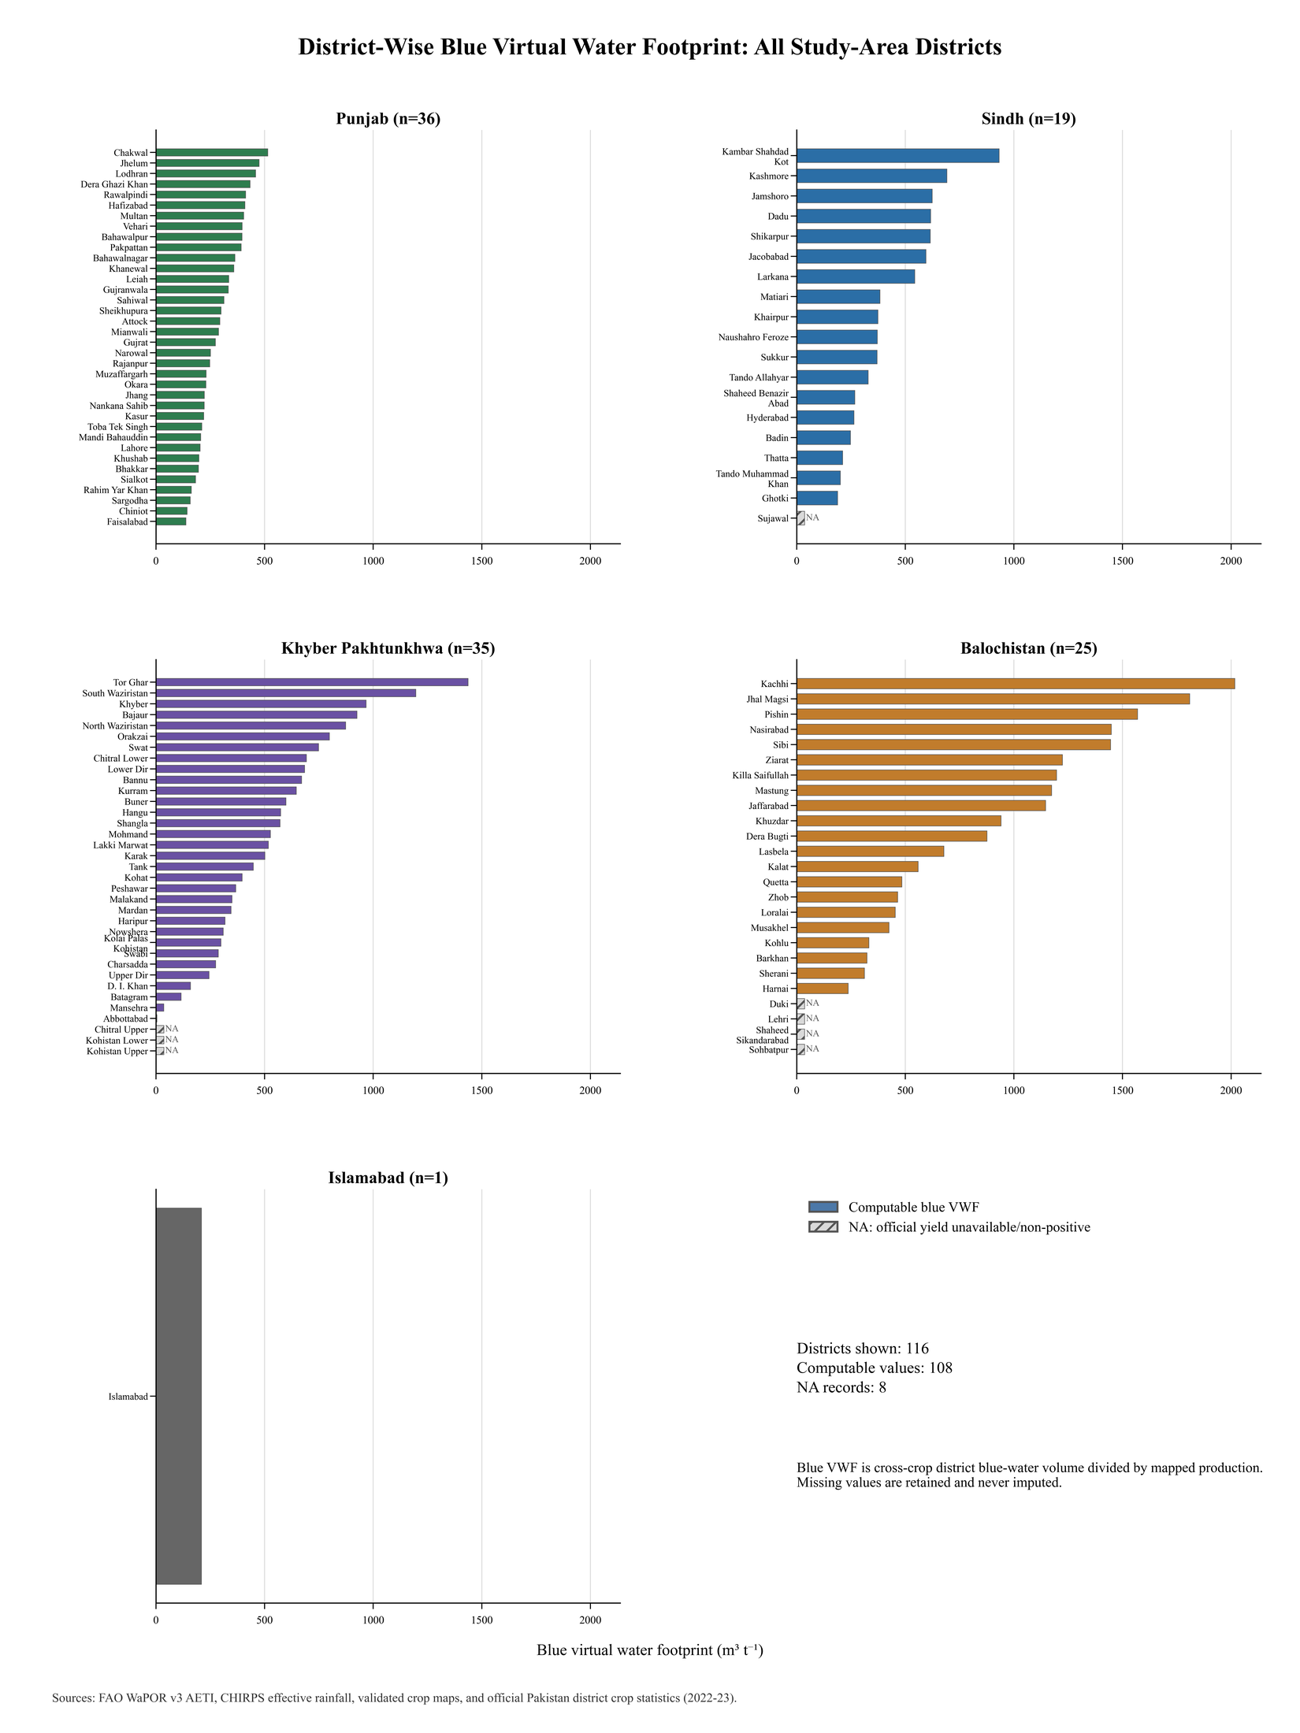
Figure S1. Full ranking of blue virtual water footprint for all 116 study-area district records; non-computable records are retained explicitly.
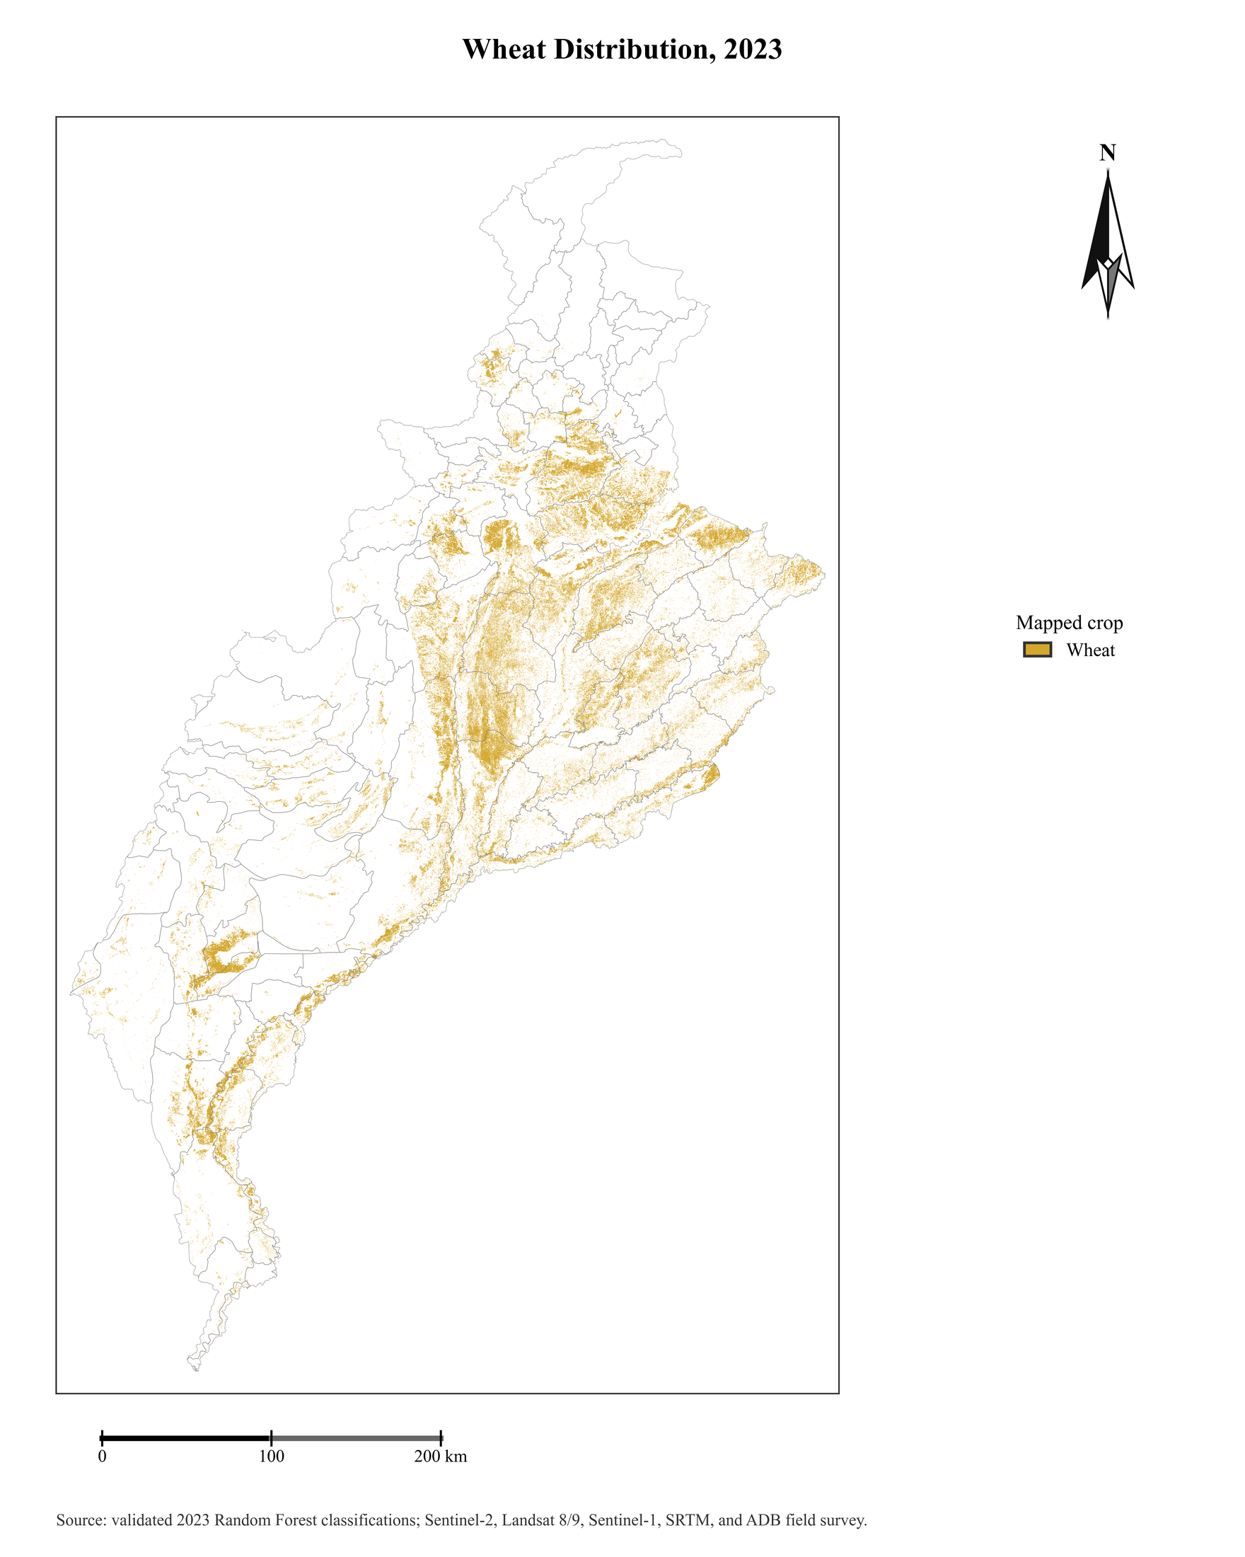
Figure S2. Mapped 2023 wheat distribution within the Pakistan portion of the Indus drainage-basin analysis boundary.
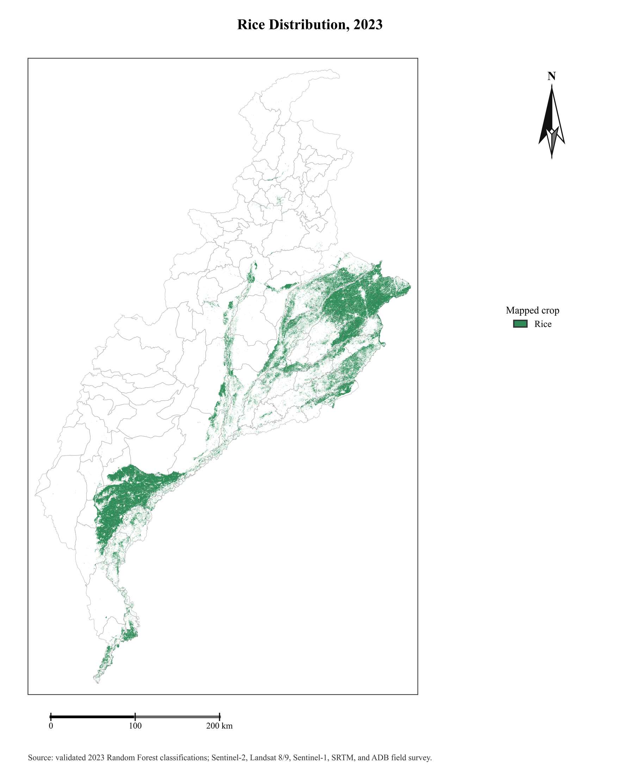
Figure S3. Mapped 2023 rice distribution within the Pakistan portion of the Indus drainage-basin analysis boundary.
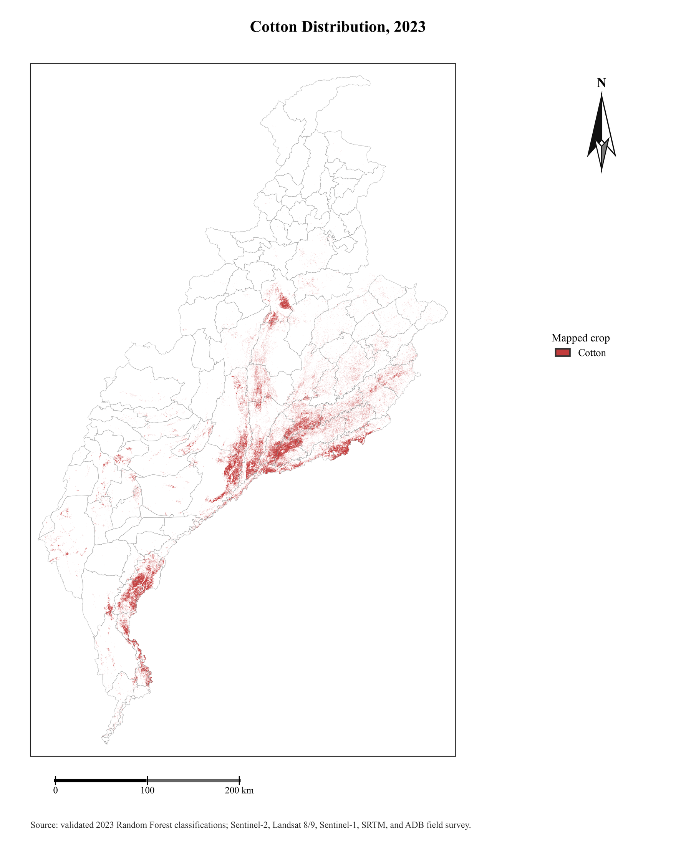
Figure S4. Mapped 2023 cotton distribution within the Pakistan portion of the Indus drainage-basin analysis boundary.
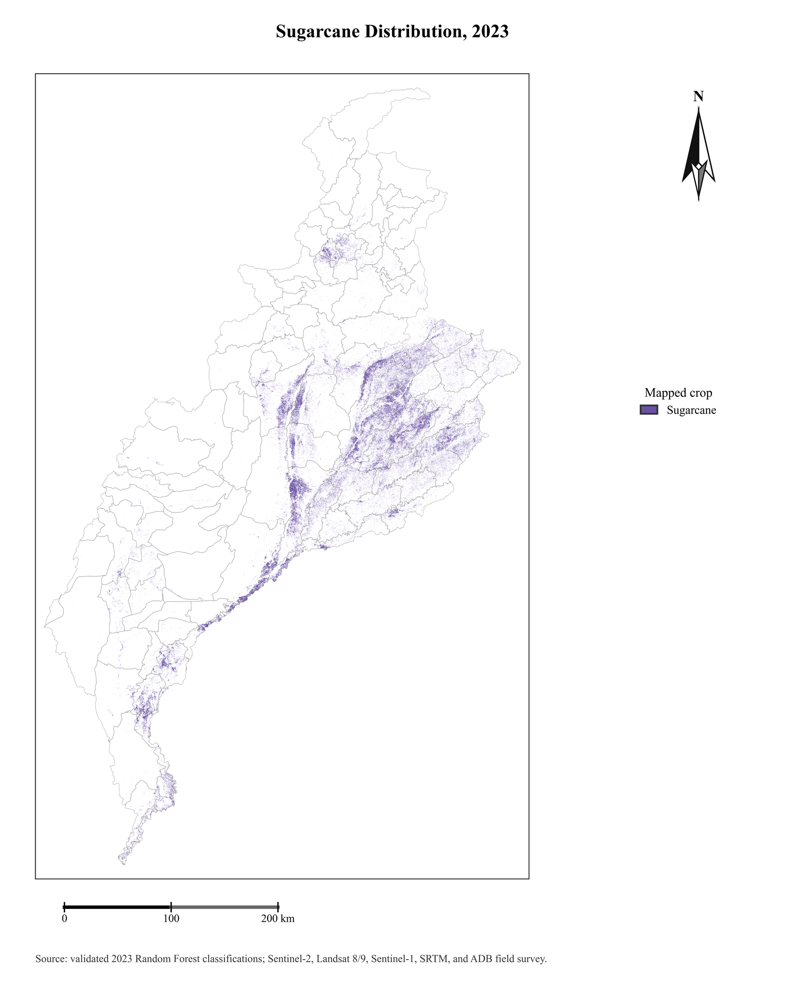
Figure S5. Mapped 2023 sugarcane distribution within the Pakistan portion of the Indus drainage-basin analysis boundary.
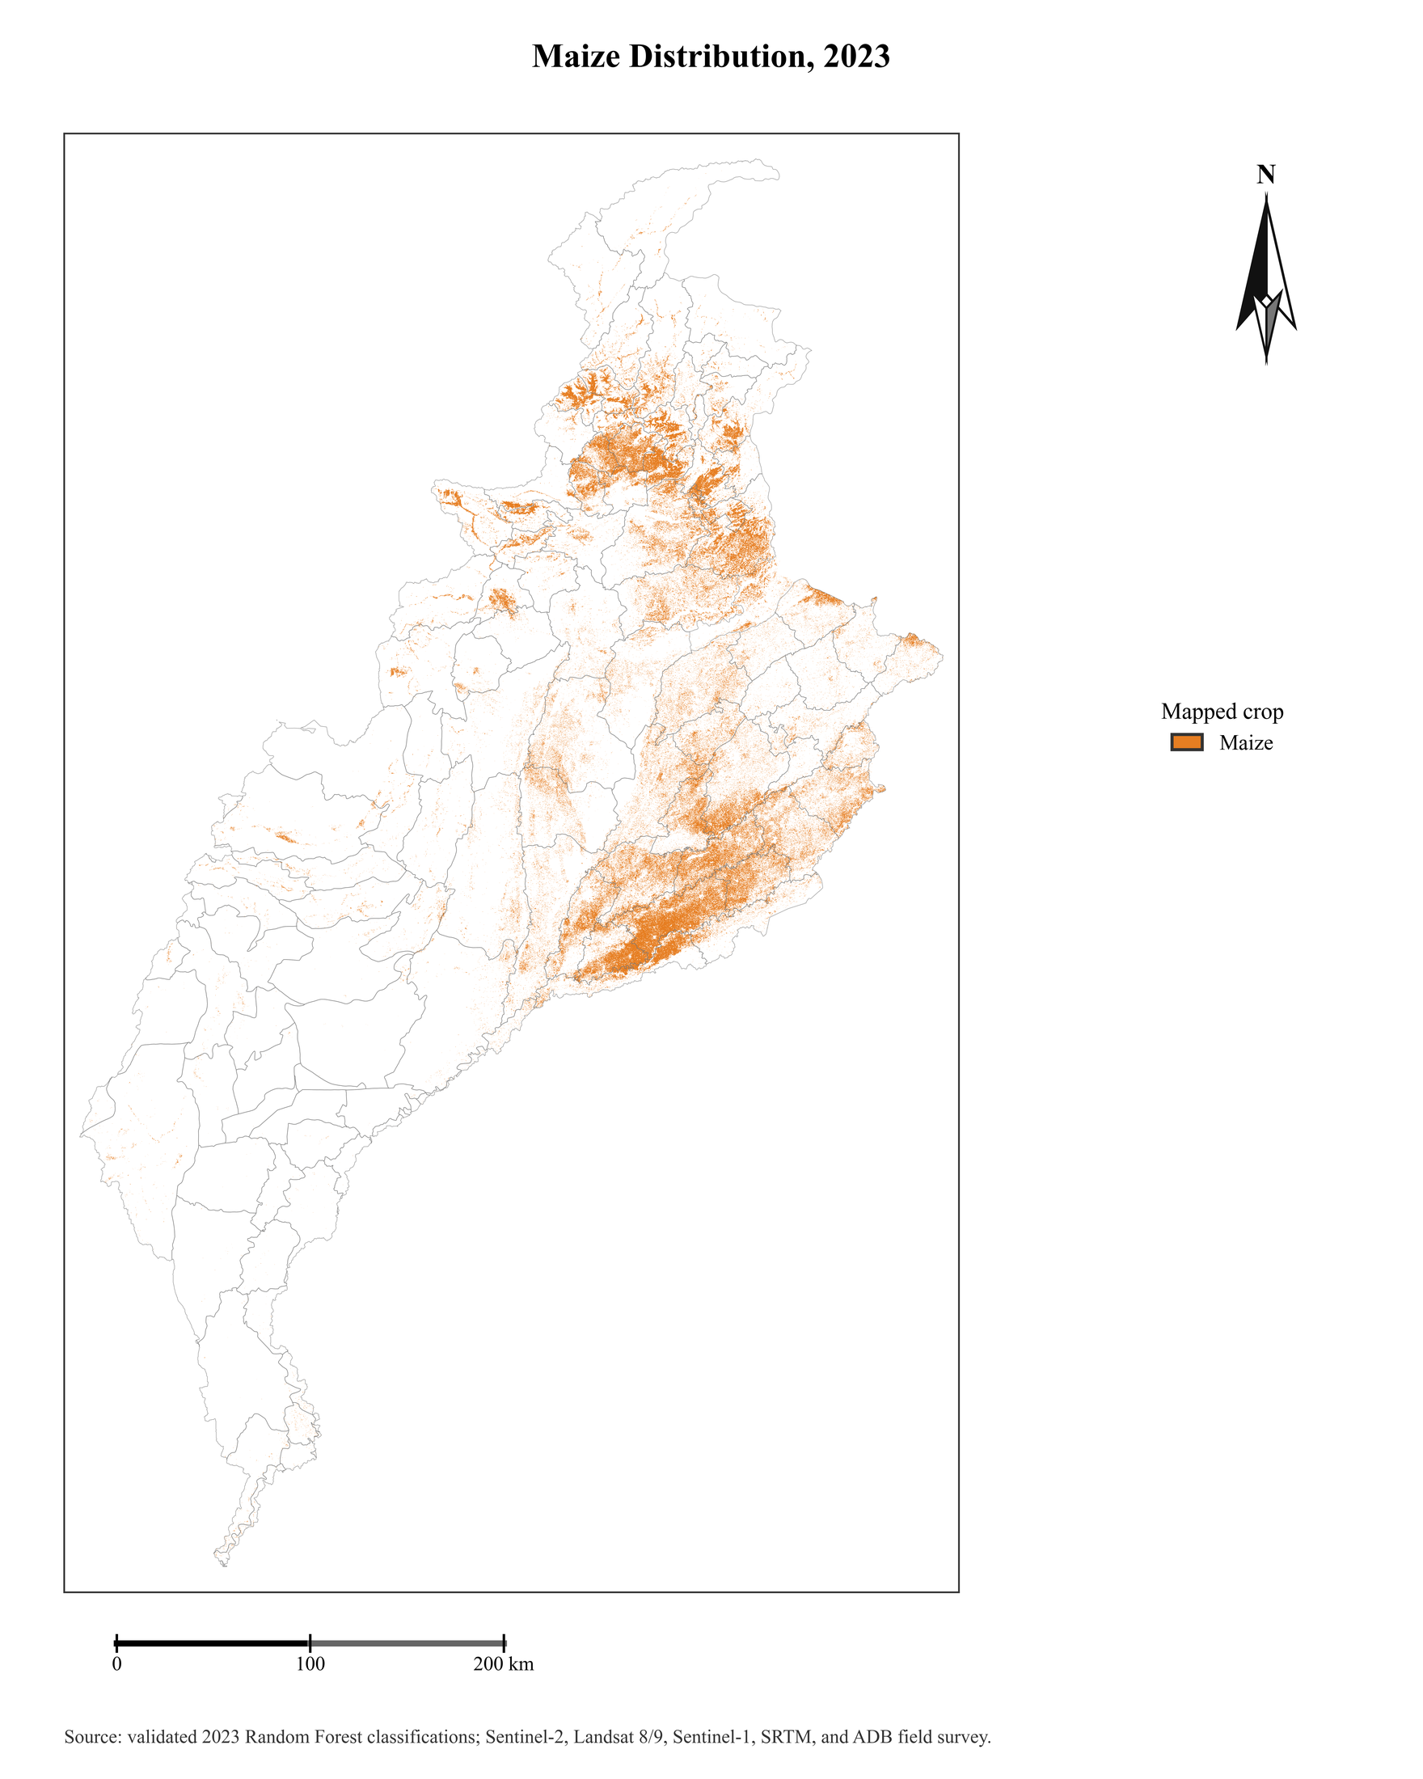
Figure S6. Mapped 2023 maize distribution, combining the spring and autumn crop cycles used in the analysis.
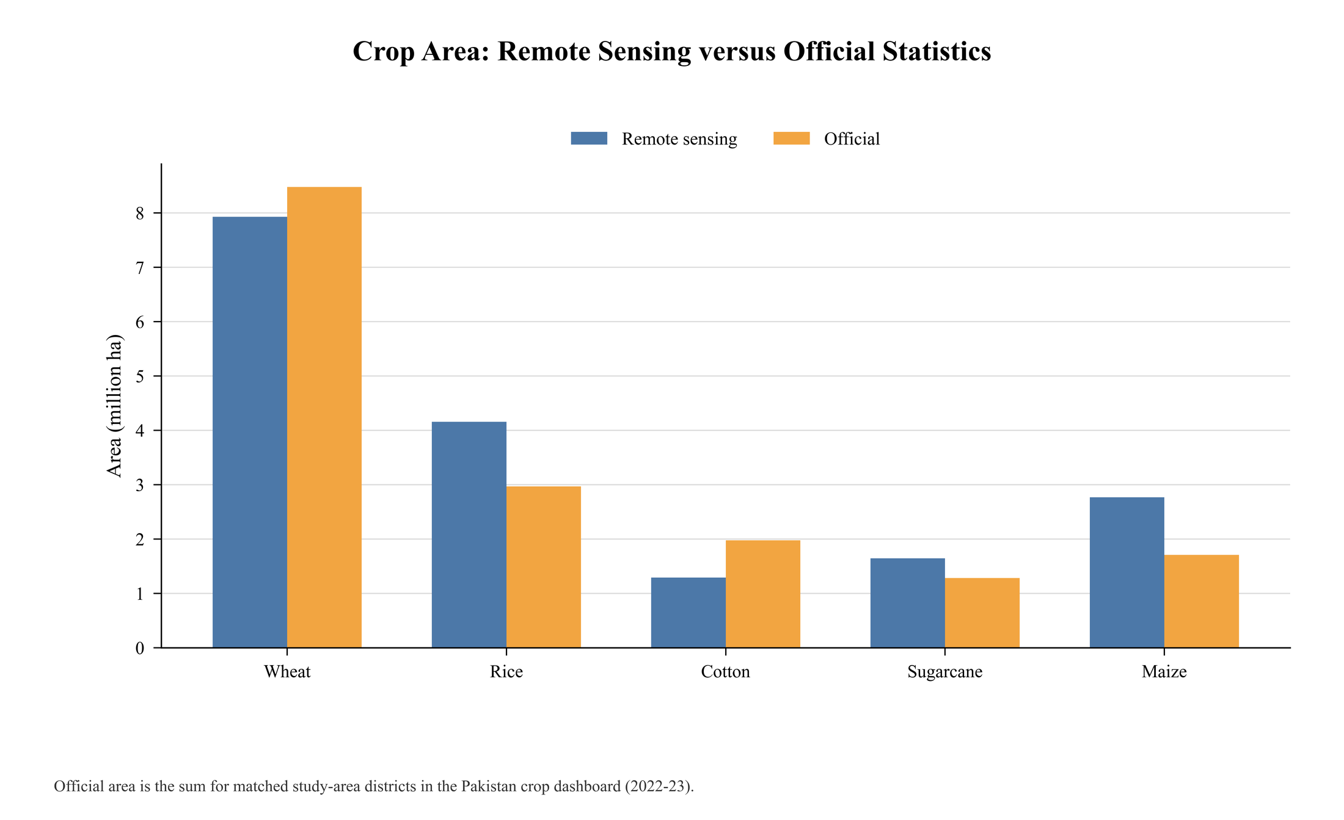
Figure S7. Remote-sensing crop-season area compared with matched official harvested-area statistics for the five target crops.
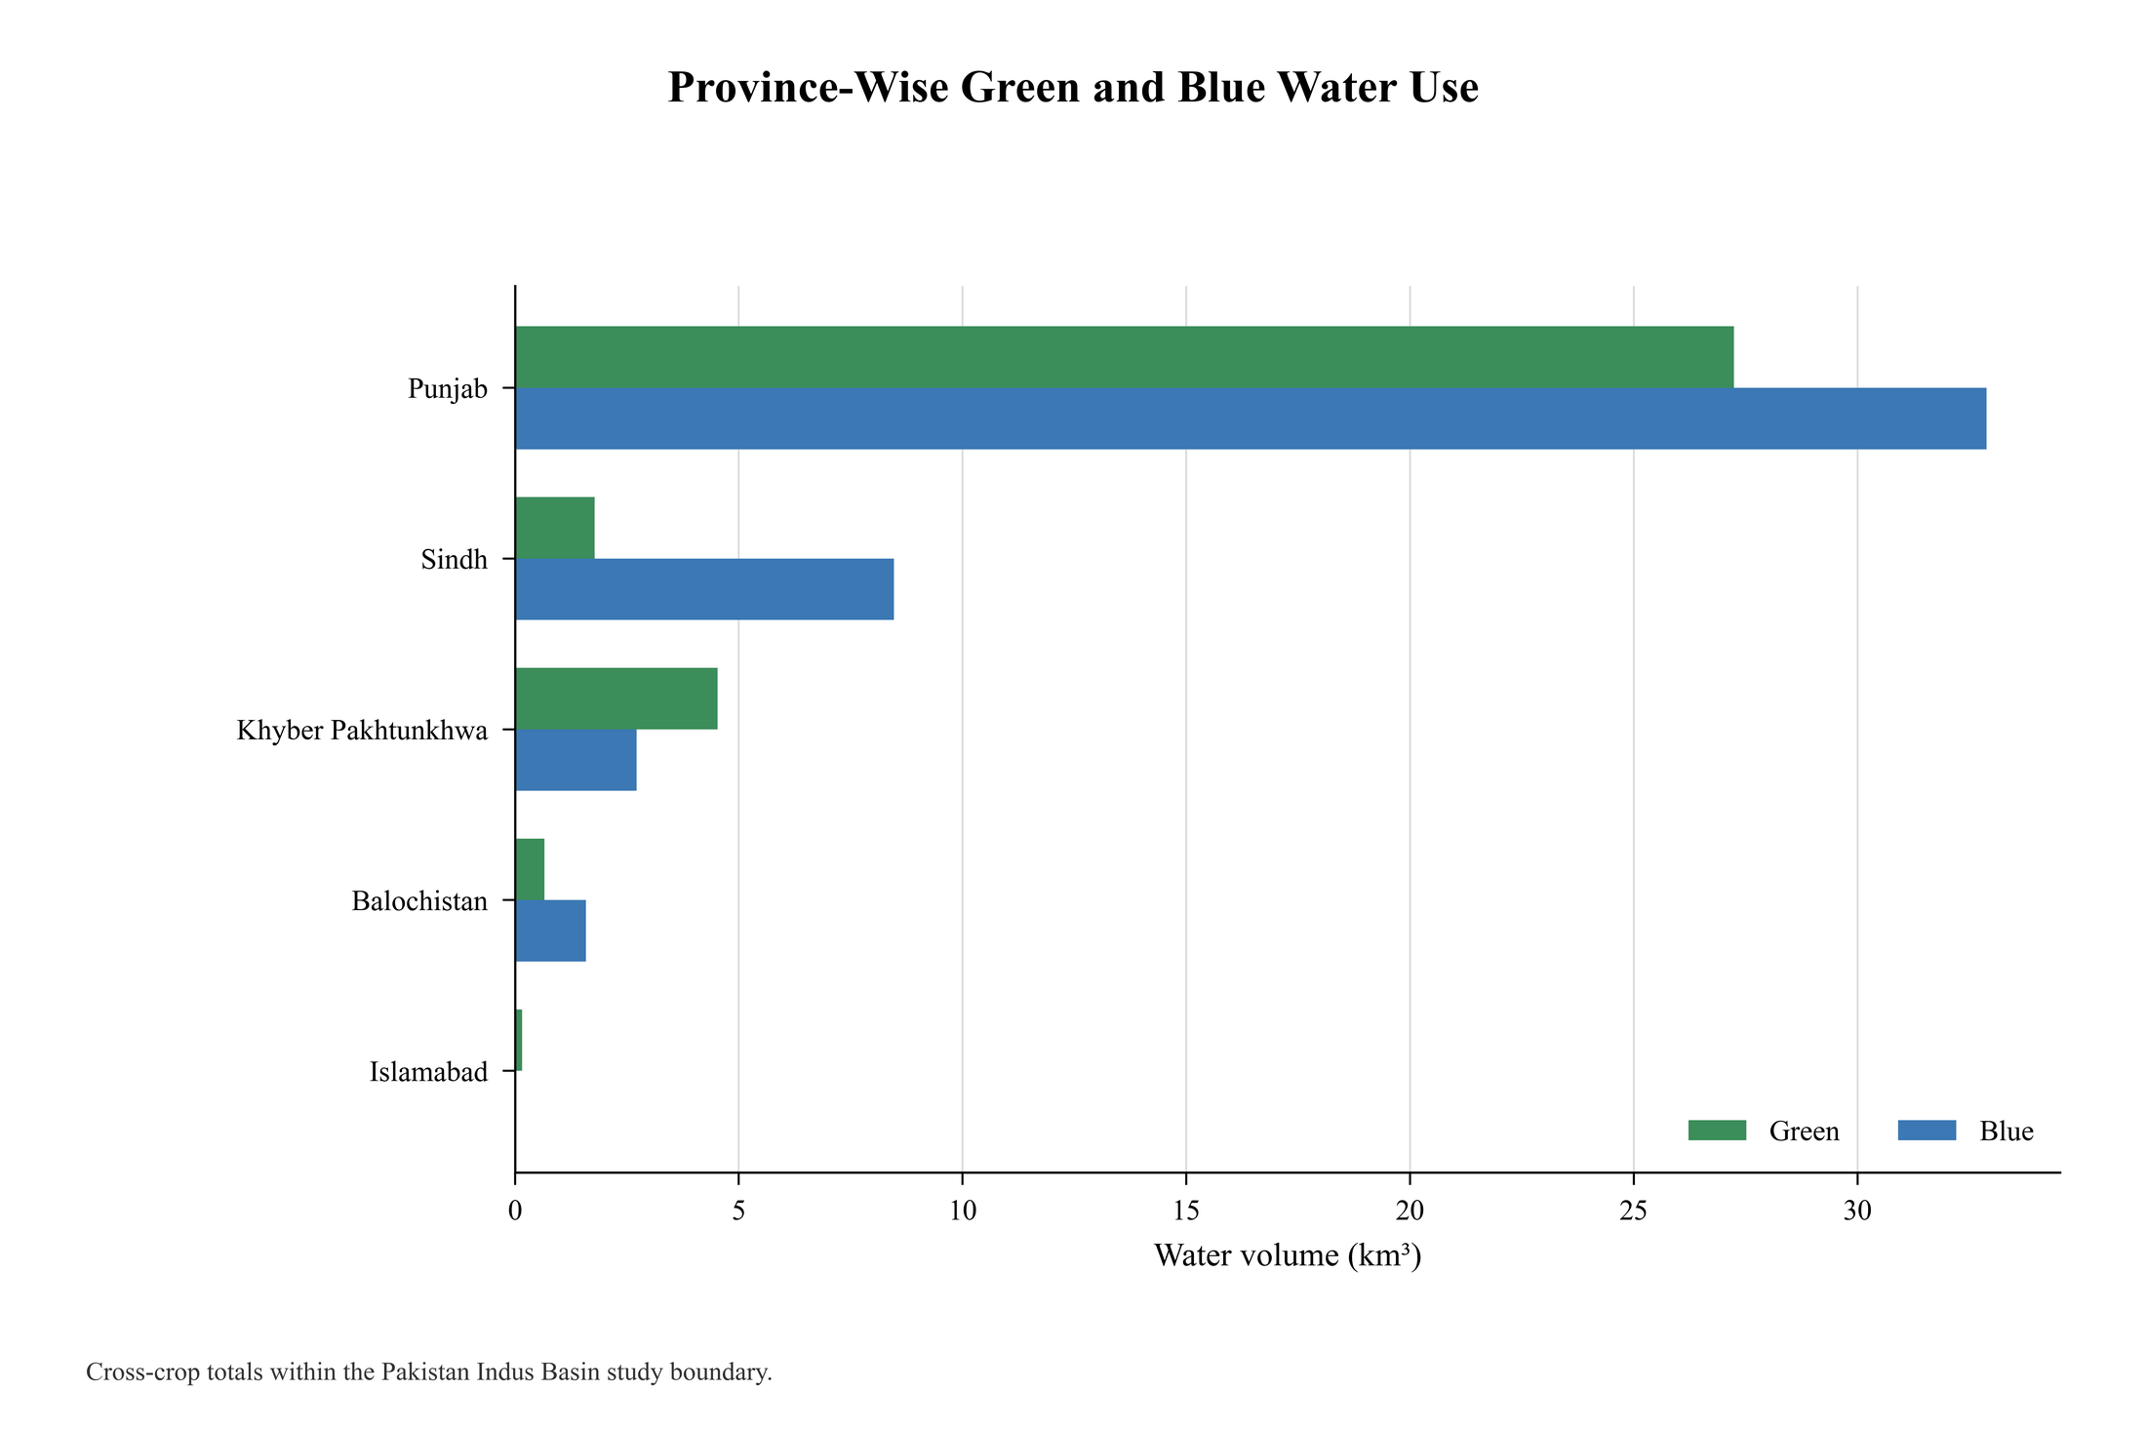
Figure S8. Province-level comparison of rainfall-attributed green and residual-blue consumptive-water volumes.
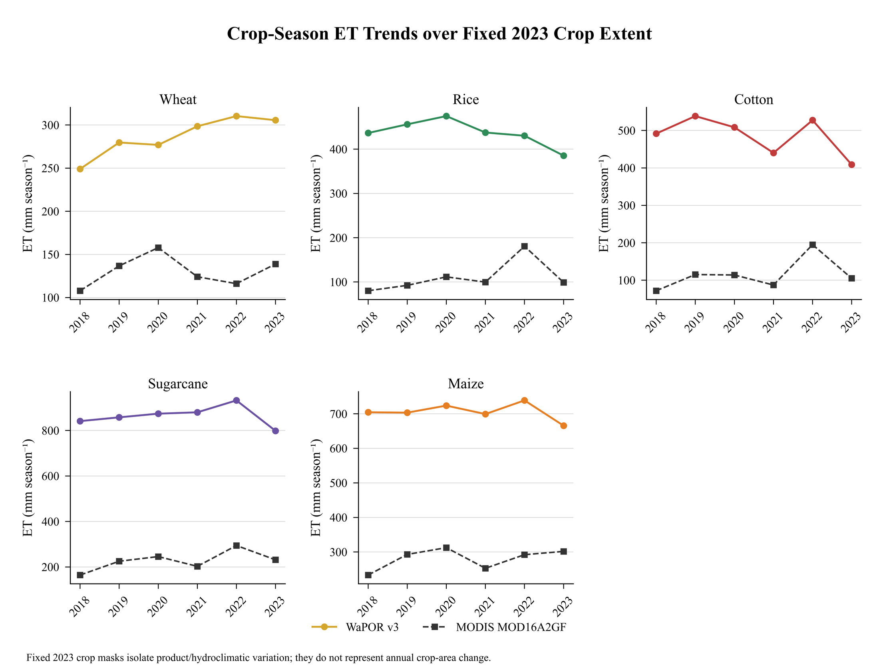
Figure S9. Fixed-2023-crop-extent evapotranspiration context for 2018-2023; the series does not represent historical crop-area change.
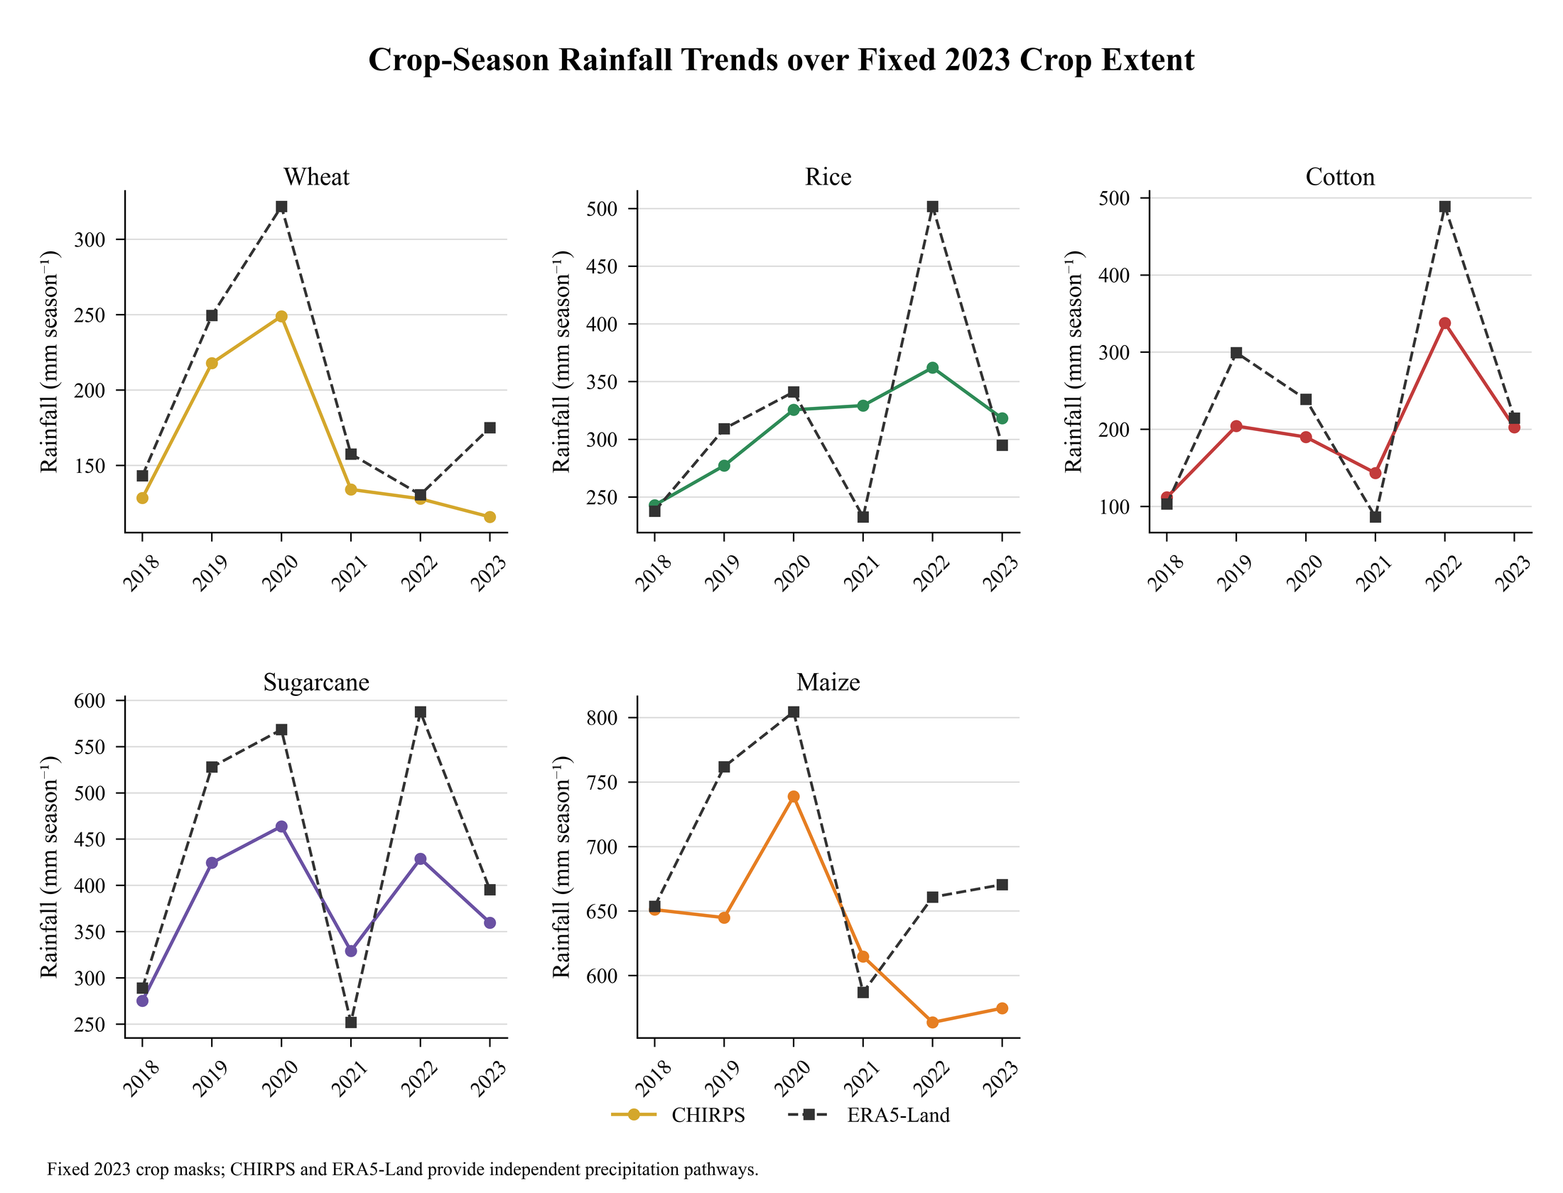
Figure S10. Fixed-2023-crop-extent rainfall context for 2018-2023; the series is a short hydroclimatic diagnostic rather than a climatology.
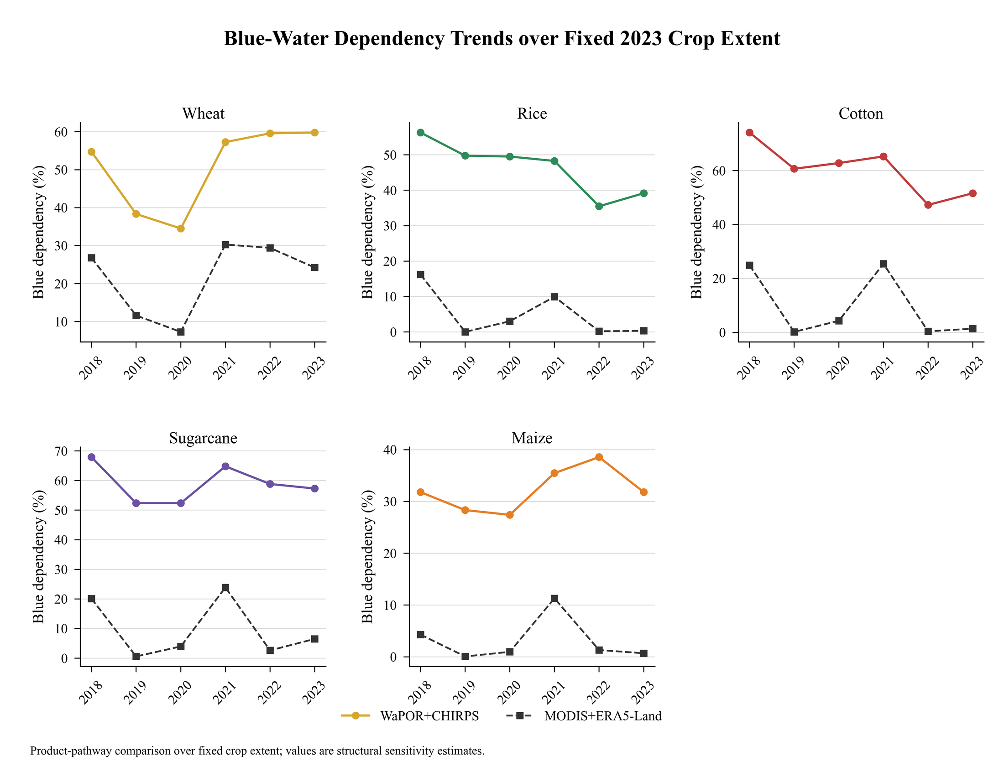
Figure S11. Fixed-2023-crop-extent residual-blue dependency context for 2018-2023.
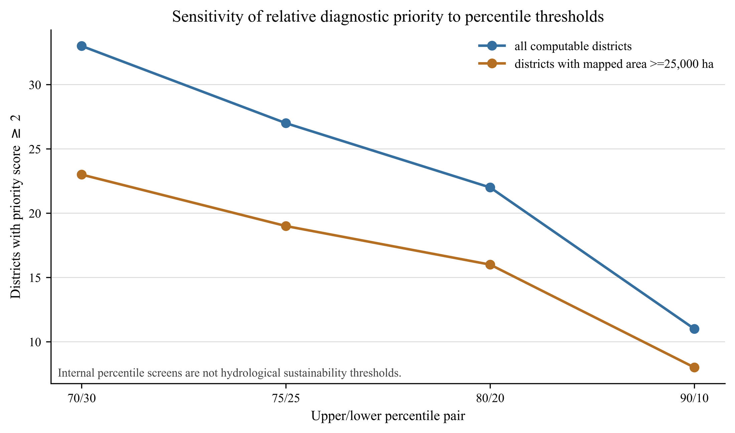
Figure S12. Sensitivity of district hotspot counts to alternative upper- and lower-quantile screening thresholds.
Figure S13. Direct two-endpoint structural sensitivity of crop total virtual water footprint. Circles show the primary WaPOR-CHIRPS estimates, diamonds show the MODIS-ERA5-Land comparison estimates, and connecting lines show the difference between the two evaluated product chains. The endpoints are not confidence limits, and no interpolation or probability distribution was used.
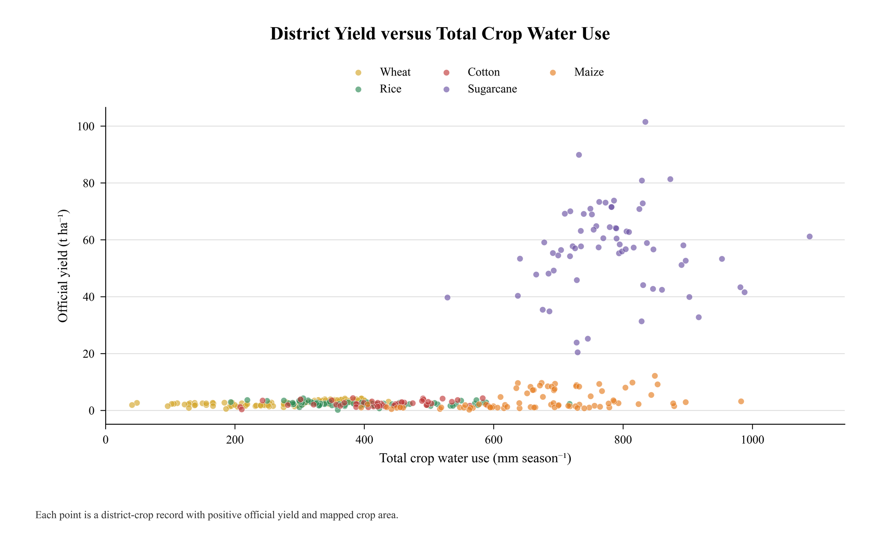
Figure S14. Relationship between matched crop yield and crop-season consumptive-water use for computable records.
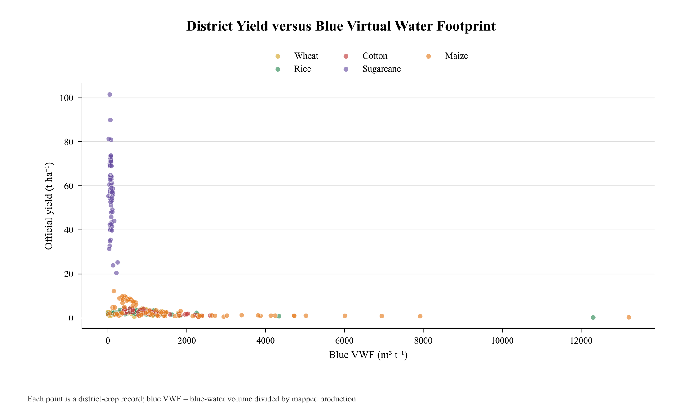
Figure S15. Relationship between matched crop yield and residual-blue virtual water footprint for computable records.
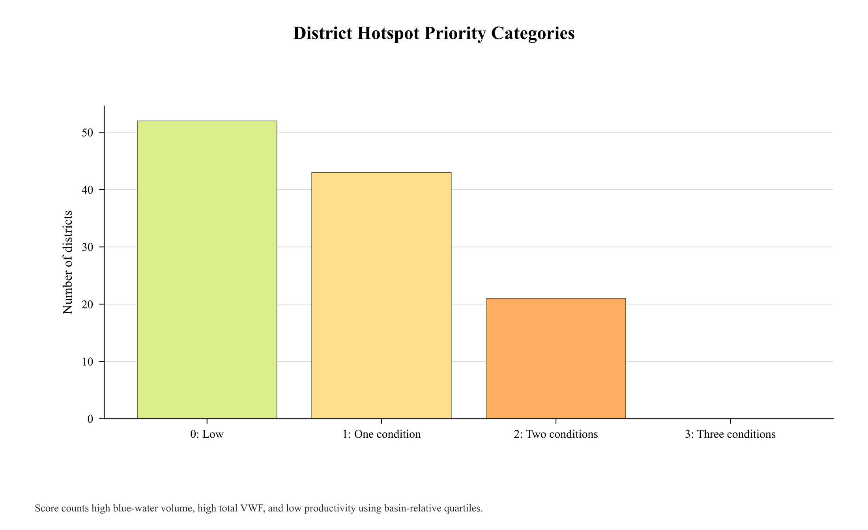
Figure S16. Counts of district records assigned to the exploratory hotspot-priority categories.
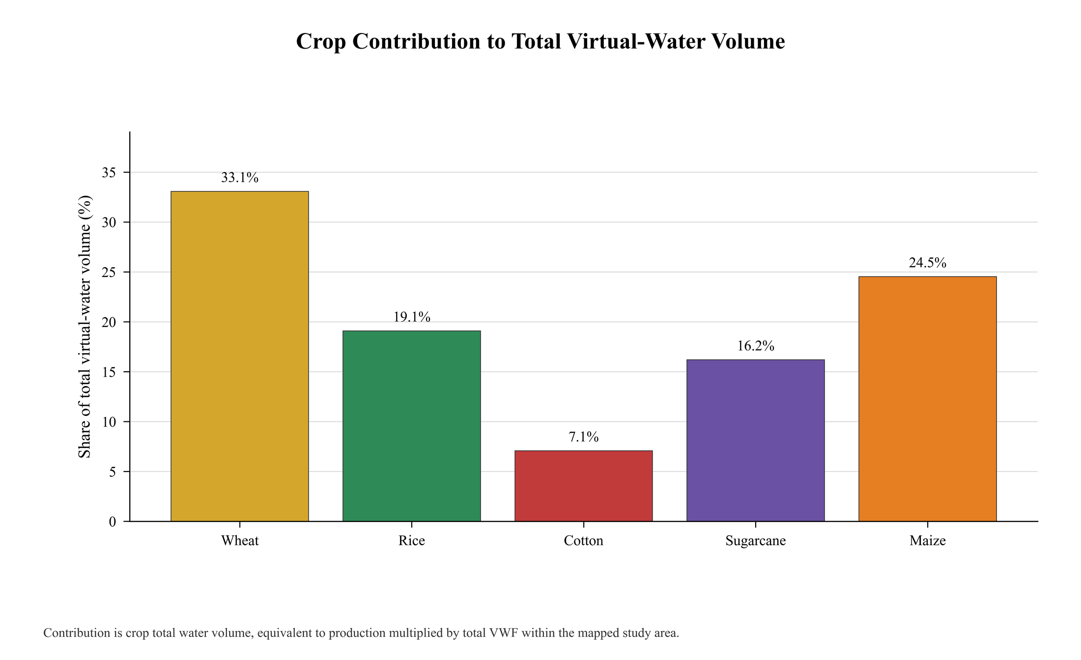
Figure S17. Crop contributions to total virtual-water volume within the mapped 2023 crop-season extent.

